Average Order Value (AOV) By Customer Rating

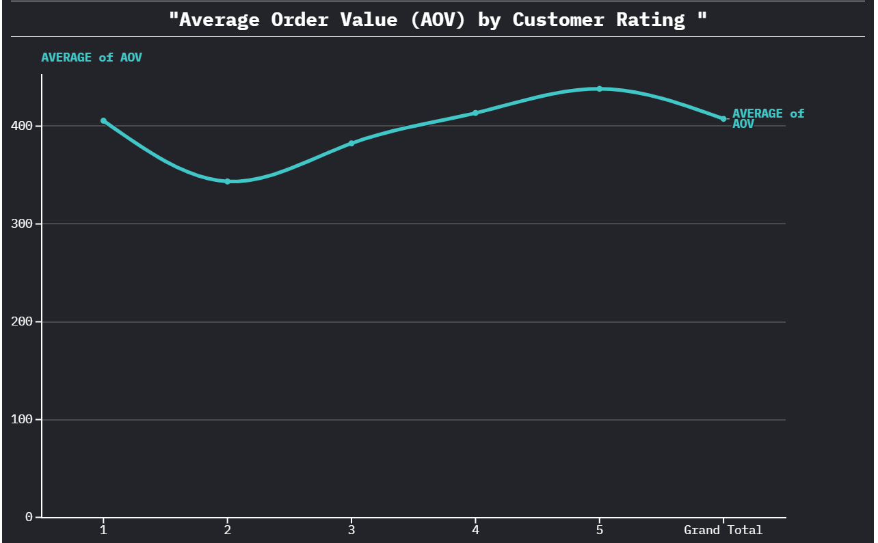

* Chart Type: Line chart
* Findings: Customers who gave higher ratings also tended to have higher order values,suggesting that satisfaction is linked with spending . Dissatisfied customers not only rate poorly but also spend less.
* Improving customer satisfaction directly increases revenue per order.

Stockouts By Product Category

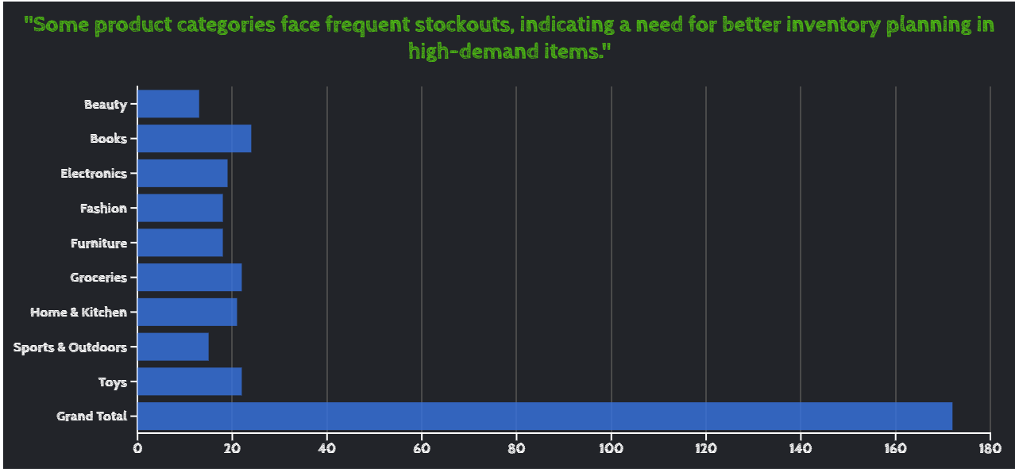

* Chart type: Bar Graph(Grouped)
* Other categories such as Beauty,Fashion,Sports & Outdoors have comparatively fewer stockouts.
* Stockouts in popular categories indicate missed data opportunities and customer dissatisfaction
* Strengthen inventory management and forecasting for high demand categories to avoid stockouts and lost revenue.

Delivery Performance By Pincode

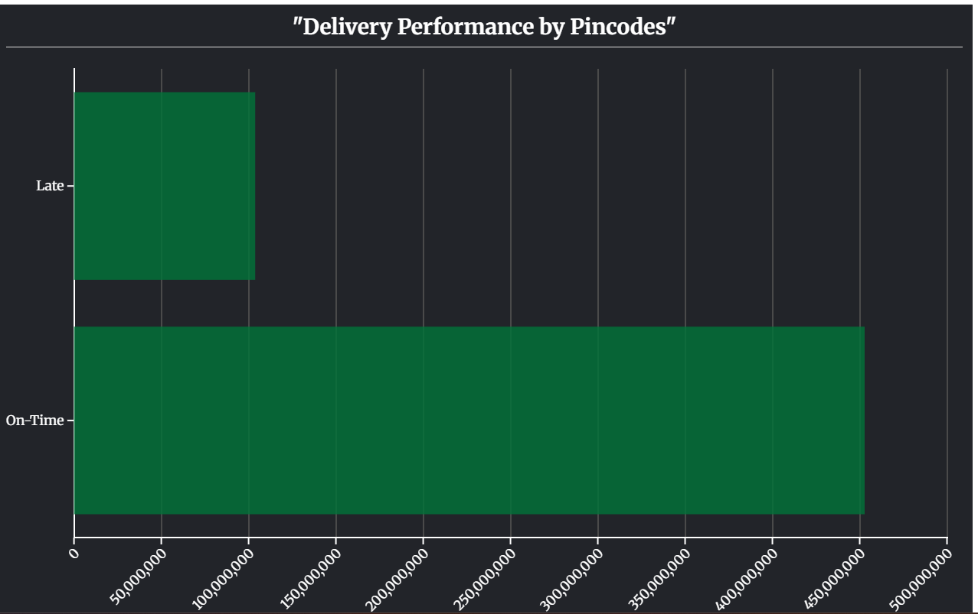

Chart Type: Bar Graph(Grouped)

* Most deliveries are on-time , which shows strong logistics performance overall.
* However , a significant portion of late deliveries exists in certain pin codes
* Delays are not uniform across regions,suggesting specific geographic challenges
* Focus on improving delivery performance in problem pin codes to enhance customer satisfaction and reduce complaints.